Assignment 8 (S520)

FNU Anirudh

October 29, 2015

solution 2

# a) Generating 4 samples from Normal Distribution with n=19  
d <- data.frame(matrix(ncol = 4, nrow = 19))  
i=4  
while (i>0){  
 x<-rnorm(19)  
 d[,i]<-x  
 i=i-1  
}  
d

## X1 X2 X3 X4  
## 1 -1.53272317 1.60487944 -0.07541228 -0.4826547  
## 2 -0.03600853 -0.23529556 -0.44803204 -0.5241822  
## 3 0.08169431 -0.87929606 -2.00627100 -0.4352119  
## 4 0.67205432 0.41749550 -0.36380116 -1.7078537  
## 5 -0.32609883 -0.32315114 0.87156747 -1.4645963  
## 6 -0.69586327 -1.37959405 -0.31727082 -0.1662459  
## 7 -0.84653693 -0.70344290 1.22584503 -0.7629906  
## 8 0.07150582 -1.46845106 0.33187508 0.2922941  
## 9 0.54902297 -1.84562924 0.87079217 -0.2923694  
## 10 2.12771897 1.14077821 -0.19817311 0.7008000  
## 11 0.54511893 -0.11901312 -0.03060624 -0.4778269  
## 12 0.93908104 -1.61172032 -1.10585205 1.0730649  
## 13 0.36897691 -1.57236175 -0.69217617 0.5968755  
## 14 1.96777958 1.91901840 -0.02815739 0.7047139  
## 15 -0.56233223 -0.01202092 1.86839482 -0.8704041  
## 16 0.33233669 -0.82273798 -0.62637023 0.1209882  
## 17 1.90919608 -0.35868639 0.65039706 1.1766840  
## 18 0.07366799 -0.70743538 1.58419423 -0.4842665  
## 19 1.61712442 1.20458935 0.48915275 0.1102594

# b) QQ Plot for each sample  
plot<-function(x) { qqnorm(x)}  
apply(d,2,plot )

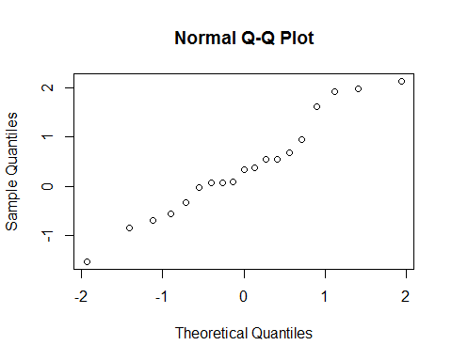 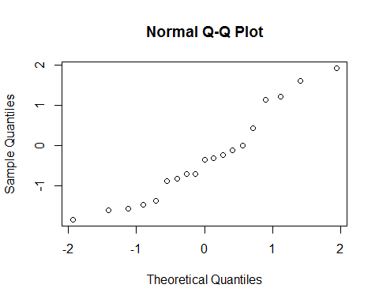 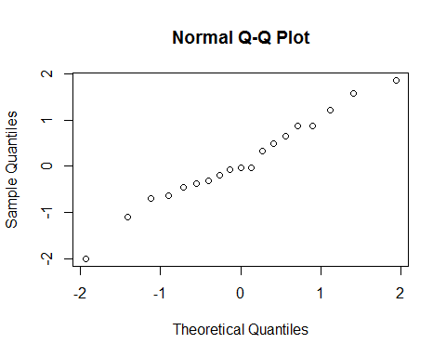 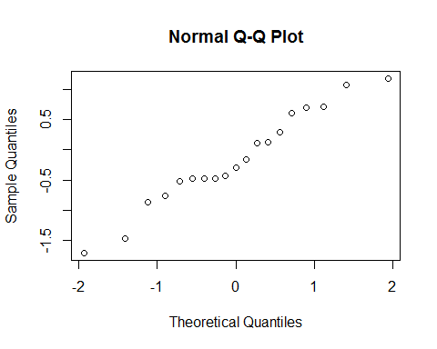

## $X1  
## $X1$x  
## [1] -1.9379315 -0.5549229 -0.1323129 0.5549229 -0.7164975 -1.1189584  
## [7] -1.4121876 -0.4067243 0.4067243 1.9379315 0.2669941 0.7164975  
## [13] 0.1323129 1.4121876 -0.8994349 0.0000000 1.1189584 -0.2669941  
## [19] 0.8994349  
##   
## $X1$y  
## [1] -1.53272317 -0.03600853 0.08169431 0.67205432 -0.32609883  
## [6] -0.69586327 -0.84653693 0.07150582 0.54902297 2.12771897  
## [11] 0.54511893 0.93908104 0.36897691 1.96777958 -0.56233223  
## [16] 0.33233669 1.90919608 0.07366799 1.61712442  
##   
##   
## $X2  
## $X2$x  
## [1] 1.4121876 0.2669941 -0.5549229 0.7164975 0.1323129 -0.7164975  
## [7] -0.1323129 -0.8994349 -1.9379315 0.8994349 0.4067243 -1.4121876  
## [13] -1.1189584 1.9379315 0.5549229 -0.4067243 0.0000000 -0.2669941  
## [19] 1.1189584  
##   
## $X2$y  
## [1] 1.60487944 -0.23529556 -0.87929606 0.41749550 -0.32315114  
## [6] -1.37959405 -0.70344290 -1.46845106 -1.84562924 1.14077821  
## [11] -0.11901312 -1.61172032 -1.57236175 1.91901840 -0.01202092  
## [16] -0.82273798 -0.35868639 -0.70743538 1.20458935  
##   
##   
## $X3  
## $X3$x  
## [1] -0.1323129 -0.7164975 -1.9379315 -0.5549229 0.8994349 -0.4067243  
## [7] 1.1189584 0.2669941 0.7164975 -0.2669941 0.0000000 -1.4121876  
## [13] -1.1189584 0.1323129 1.9379315 -0.8994349 0.5549229 1.4121876  
## [19] 0.4067243  
##   
## $X3$y  
## [1] -0.07541228 -0.44803204 -2.00627100 -0.36380116 0.87156747  
## [6] -0.31727082 1.22584503 0.33187508 0.87079217 -0.19817311  
## [11] -0.03060624 -1.10585205 -0.69217617 -0.02815739 1.86839482  
## [16] -0.62637023 0.65039706 1.58419423 0.48915275  
##   
##   
## $X4  
## $X4$x  
## [1] -0.4067243 -0.7164975 -0.1323129 -1.9379315 -1.4121876 0.1323129  
## [7] -0.8994349 0.5549229 0.0000000 0.8994349 -0.2669941 1.4121876  
## [13] 0.7164975 1.1189584 -1.1189584 0.4067243 1.9379315 -0.5549229  
## [19] 0.2669941  
##   
## $X4$y  
## [1] -0.4826547 -0.5241822 -0.4352119 -1.7078537 -1.4645963 -0.1662459  
## [7] -0.7629906 0.2922941 -0.2923694 0.7008000 -0.4778269 1.0730649  
## [13] 0.5968755 0.7047139 -0.8704041 0.1209882 1.1766840 -0.4842665  
## [19] 0.1102594

# c) ratio of Interquantile range to standard deviation for each sample  
x<-c()  
ratio<-function(x) { IQR(x)/sd(x)}  
x<-c(x,apply(d,2,ratio))  
x

## X1 X2 X3 X4   
## 0.9850215 1.1855577 1.2302576 1.2014168

# d) After trying in R, It is quite plausible to say that x bar was drawn  
# from normal distribution  
# 2.  
z<-c(1.1402,-1.8658,0.8520,-1.8251,0.8530,-0.0589,-1.6554,-1.7599,-1.4330,  
 -1.3853,2.9794,2.4919,2.1601,2.2670,-0.5479,-0.7164,0.6462,  
 -0.8365,1.1997)  
tval= ((mean(z)-0)/(sd(z)/sqrt(19)))  
tval

## [1] 0.3545188

pval<- 1-pt(tval,18)  
pval

## [1] 0.3635348

ci<- mean(z)+c(-1,1)*qt(.950,18)*sd(z)/sqrt(19)  
ci

## [1] -0.5131008 0.7768166

# Since P value is so high , we cannot reject null hypothesis HO:?? ??? 0  
# 3  
z<- sort(z)  
z

## [1] -1.8658 -1.8251 -1.7599 -1.6554 -1.4330 -1.3853 -0.8365 -0.7164  
## [9] -0.5479 -0.0589 0.6462 0.8520 0.8530 1.1402 1.1997 2.1601  
## [17] 2.2670 2.4919 2.9794

k<- qbinom(0.05,19,0.5)  
k

## [1] 6

# K=6 and 90% Confidence Interval of median (xk+1, xn-k) = (x7,x13)  
z[7]

## [1] -0.8365

z[13]

## [1] 0.853